CHrist Episcopal college Interns 2019-2020

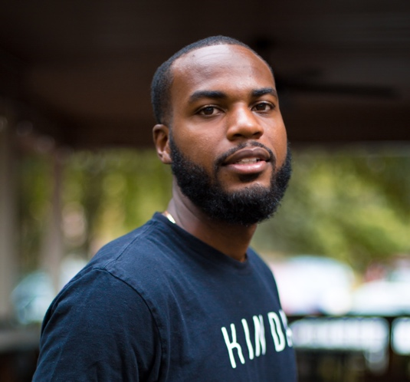
Antonio
My name is Antonio Scantlebury, a graduate student at Valdosta State University majoring in Communications. I am originally from the Bahamas and moved to Georgia in the 11th grade of high school. I have been a part of Christ Church and its college ministry since 2015, my freshman year. I am pleased and very proud to have witnessed what the ministry has evolved to in this short time, and I am excited to see how students will be blessed moving forward. One thing I can say is that this parish has always done a tremendous job of turning new faces into family. Thank You Christ Church!

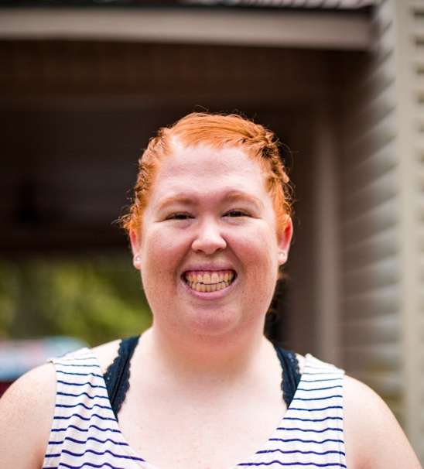
Erin

HI! My name is Erin Cole, I am from Suwanee, GA. I was born and raised in Georgia. I graduated with my bachelor’s degree from VSU in December 2018. I am currently a graduate student here at VSU. I am getting my Masters of Education in Counselor Education. This is my second year as an intern at Christ Church. I have been involved since dinners were held at Steph’s house and I have continued to see it grow and build over the years! Grace Café has allowed me to come out of my shell and has given me plenty of opportunities to learn, grow and have new experiences. Grace café is a home away from home and I have made tons of memories and lasting friendships. The opportunity to be an intern has allowed me to become more involved in the community and has helped my faith grow. I am so thankful to have this opportunity to be an intern for Christ Church/Grace café. I am very excited to see what this year brings!!!

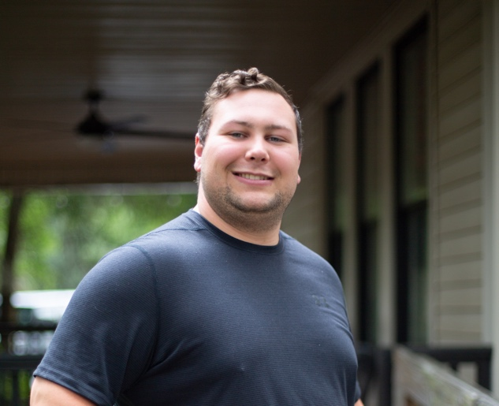
Will
Hello, my name is Will Sandridge and I’m from Saint Simons Island Georgia. I love football, free food and fast cars. In my life I appreciate hard work, honesty, and happiness. I’m starting my third year here at VSU, and plan to double major in Finance and Accounting. Some extracurricular activities I am an elder member of the asset management team in the Investment Club, Chapter Chairman for the VSU College Republicans, and a member of the Honors Student Association. Those things may sound time consuming, but in the center of all those responsibilities is my relationship with God. I may grow weary and become distracted at times, but I never forget who is in control and who truly loves me. He is the rock I stand on mentally, morally, and emotionally. I can’t describe the excitement I had when I was welcomed into this new church and became an intern with the Grace Café. I couldn’t think of a better place, better time, better outlet for college Christians to come together and share a meal with their friends in hopes to bring them to Christ. I would like to end by thanking the members of the church for supporting Grace Café and giving us your blessing as we continue to make a difference in students’ lives here at VSU.

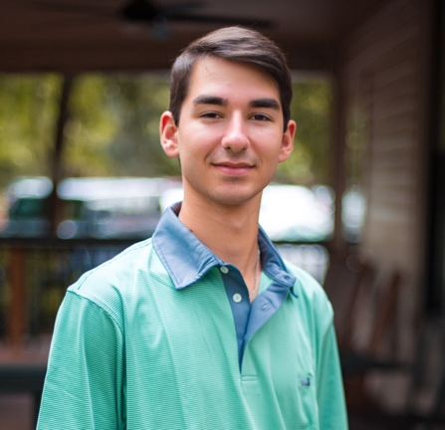
Alex
Hello, my name is Alex Jones. I’m currently a junior at VSU, majoring in Biology/Pre-Vet. I moved to Valdosta in middle school due to being a military family. I graduated from Valwood in the spring of 2017. When I’m not busy with school, I like to spend my time either fishing, in the woods, golfing, or playing guitar. I also enjoy watching football and attending baseball games. Another hobby of mine is hanging out with my friends or my fraternity
brothers. Within the past year, I’ve also been blessed with an opportunity to be an intern at Louttit, which we call Grace Cafe. One reason I wanted to pursue this opportunity is because it enabled me to branch out and meet more people. I also get the opportunity to study in a quiet and comfortable place instead of spending the night in the library on campus. Last but not least, I get to watch the youth here grow as they look up to me as a role model. Thank you Christ Church!
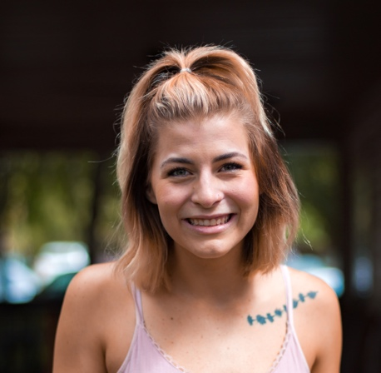
Emily
Em here! I am a junior at VSU and this is my second-year interning at Grace. I am majoring in Political Science with the intent to go to law school after graduation. I really love reading, writing, yoga, and cats. Christ church has been my home ever since moving to Valdosta with my family in 2014. I am so thankful for Christ church taking a chance and investing in the cafe. Grace has become a home and safe haven for many VSU students and an incredible outreach program. Grace Cafe is truly something special and I am so excited for the year to come!
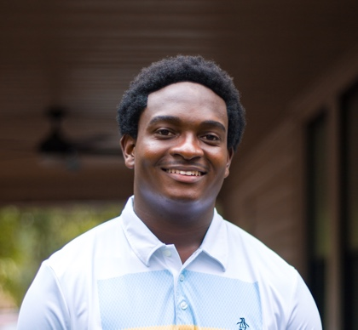
Patrick
Hi my name is Patrick Lee. I am a junior at Valdosta State University majoring in mechanical engineering. I love playing pretty much every sport and I am competitive by nature. I am currently a 2nd year intern at Grace Café -- which I’m so thankful for!! Among other things, being an intern allows me to be independent in the town I grew up in, while serving my fellow college community. Thank you Christ Church!!!

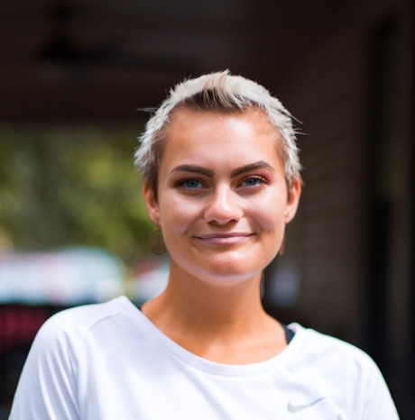
Shelby
My name is Shelby Coulter. I am a senior at Valdosta State University studying fine arts and graphic design. This is my second year being an intern for Christ Church. Having this opportunity has been such a blessing. Being an intern has allowed me to be more involved with the community and step out of my comfort zone. It has definitely helped my relationship with God. I have created many life-long relationships. Watching Grace Café grow so large and watching it touch so many hearts is phenomenal. We have all become this big family that will continue to grow. I can’t wait for the memories to come. Thank you, Christ Church!

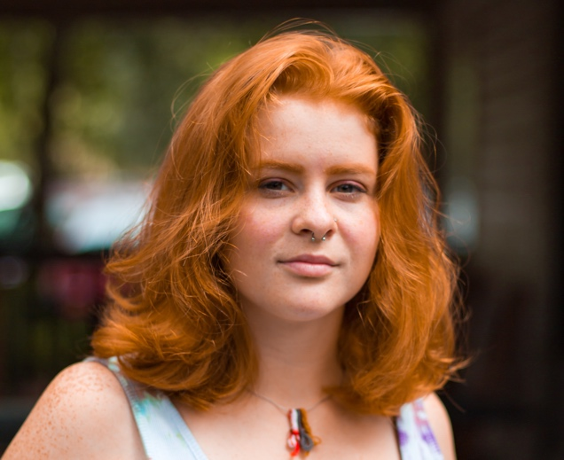
Isabelle
My name is Isabelle Redenius. I am going into my third year at VSU for a BFA. Although This will be my first official year interning for Christ Episcopal Church, I will say that the past two semesters attending grace cafe functions and meeting the other interns has completely changed my college experience. I have met people that will be in my life for a very long time. I am incredibly thankful for the opportunity to be an intern here! Thank you so much!!
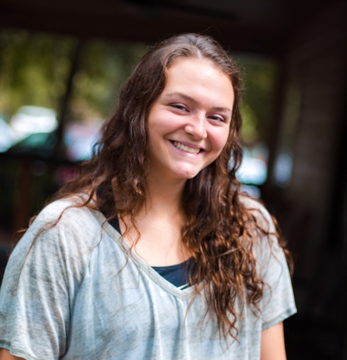
Emily
Hey y’all!! It’s me, Emily the newest intern!! I am a freshman this year and planning to go through with a degree in health science--Physical Therapy. Grace Cafe is a blessing that found me, and is continuously giving me a bigger family!!!❤️ I’m looking forward to the experience I will have and the memories I will make. THANK YOU Christ Church for making this possible!

